Component Diagram: Smart City Brisbane Sprint 2

Update the user and WebUser database

Authenticate through the database

Update the password of the user database if details are confirmed

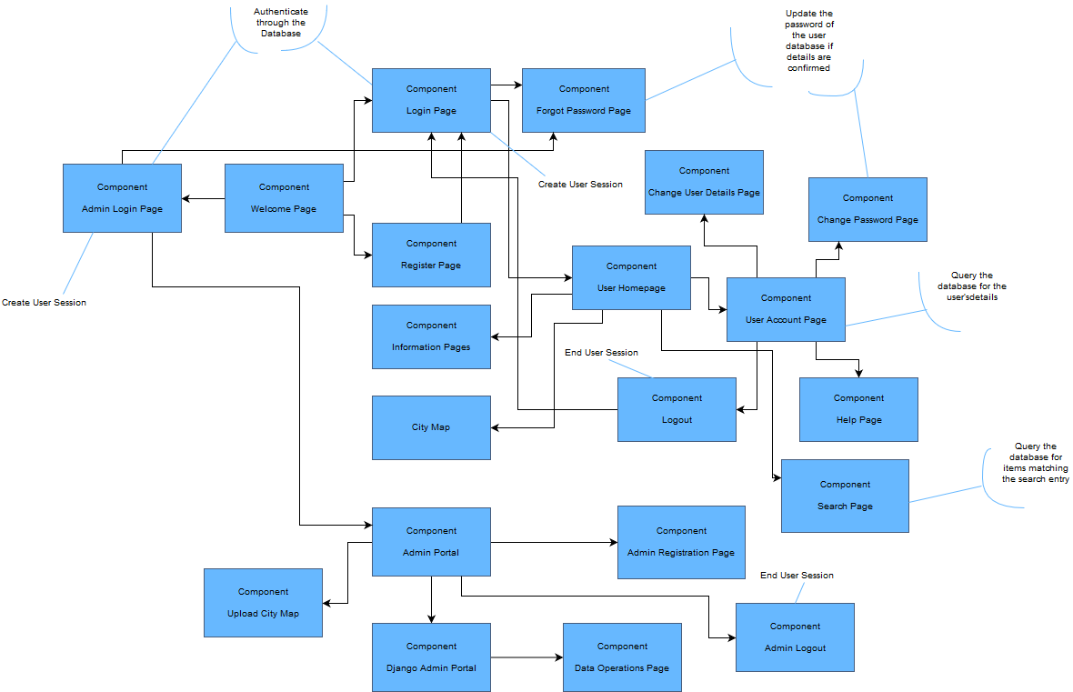

The welcome page will provide an introduction the website and the type of accounts the user can create when using the smart city Brisbane website. From this welcome page they can access the help page, register page and login page. The login page will ask the user for their username and password. If the details of the user are found in the database a session for the user will be created and redirected to the account homepage for the user. If the details are wrong the user will be presented with a login error. Additionally, the user can recover their password by clicking on the “Forgot Password” link which will open a forgot password page asking for the email and username of the user. If both details are found within the database and are verified to that user the database will set a temporary password and inform the user that they can login with that password. If the user is new to the website and has yet to make an account then the registration page will provide a form in which they can provide details unique to themselves. The site will then validate this to prove that none of the details enter match any existing members. If this condition is met an account is made and the user now has full access to the site and account page. The registration form will ask for username, Password, email, group, first name, last name, address and phone number. After successfully registering the user will be relocated to the login page where they can use their credentials to log in and access the website.

Once the user has been verified and logged in the user is presented with the account page. This account page will be the pivotal point for personal details and help. From this page users can access the help page, logout page, change user details page and change user password page. These will all be links present on the form of the account page. If for some reason the user is not on the account page and wish to access this it, a link will be present in the side menu that will link the user back to their account page. The help page will provide the basic details on how to use the site, the difference between account types and other miscellaneous facts. It will also have a link back to the account page for the user.

Once at the account page the user is presented with their current account details which have been retrieved from the users and WebUsers database. The user can view their information. If the user wants to change their account details they can navigate to the change user details page which they can edit the following username, email, phone number, address and name. If the user tries to use a username or email already in use the form will reject it and ask the user if they can provide another username or email. If the form accepts the input the user has provided it will save and update the database. The user can also access the change password page which will ask the user for the current password and password they wish to change it to. If the details are correct the database will update their password. Once the user is finished with the website the user can logout so no one can access their account. The logout page will be accessible from the account form and will be a simple link to a new page. Once on this page the site will confirm if they wish to logout. If they confirm then the site shall end the current user session and logout the user. Should they decline, the site will continue the session and relocate the user to their account page again.

If the user decides to click on an information page they will brought to the page where they can view the information that’s has been entered for that type of information. The user can additionally click on city map to view the map that has been uploaded by an administrator. The information from the pages are queried and pulled from the database and then are linked through the template using the Django framework. This also applies for the city map but instead just retrieves the image link and renders it as an image.

The search page allows a user to search the website for specific locations. The user enters their query into the search form, and the page will return all locations containing the text entered. After searching, the form is still present on the page, allowing the user to continue to search without having to return to the previous page.

The Admin pages allow an administrator to perform various functions related to the management of the website. First, the administrator will log in using the Admin Login page. Their entered credentials will be verified, and they will then reach the Admin Portal. From there, the administrator can go to the Upload City Map page, with allows them to upload a new city map to the website, which is stored on the server’s filesystem. The administrator can also go to the administrator registration page, which allows them to create an account for a new administrator. This page asks for the same information as the standard registration page, with the exception of the ‘user type’ field. The administrator can also access the Django Admin Portal, which allows them to add and change data in the website’s database.